实验4 信号量

实验目的
- 加强对进程概念的理解。
- 进一步了解并发执行的实质。
- 分析进程争用资源的现象，学习解决进程互斥的方法
- 了解Linux系统中进程通信的基本原理

实验内容
- 使用信号量实现有限缓冲区的生产者和消费者问题
- 使用信号量实现读进程具有优先权的读者和写者问题

实验环境
ubuntu-22.04.5

实验中遇到的主要问题及其解决方式
由于代码量偏大，使用gcc调试起来很麻烦，一些拼写错误不容易检查。共享到本机上，使用vscode等编译器能方便检查。

源代码
//lab4_1.c
#include<stdio.h>
#include<stdlib.h>
#include<time.h>
#include<unistd.h>
#include<sys/types.h>
#include<sys/ipc.h>
#include<sys/sem.h>
#include<sys/wait.h>
#include<sys/mman.h>

#define BUFFER_SIZE 5
#define MAX_ITEMS 10

typedef struct
{
int buffer[BUFFER_SIZE];
int in;
int out;
int count;
int produced_count;
int consumed_count;
}shared_data_t;
struct sembuf P={0,-1,SEM_UNDO};
struct sembuf V={0,-1,SEM_UNDO};
#define MUTEX 0
#define EMPTY 1
#define FULL 2
int create_semaphores()
{
int semid;
key_t key;
if((key=ftok(".",'S'))==-1)
{
printf("ftok");
exit(1);
}
if((semid=semget(key,3,IPC_CREAT|0666))==-1)
{
printf("semget");
exit(1);
}
return semid;
}
void init_semaphores(int semid)
{
if(semctl(semid,MUTEX,SETVAL,1)==-1)
{
printf("semctl MUTEX");
exit(1);
}
if(semctl(semid,EMPTY,SETVAL,BUFFER_SIZE)==-1)
{
printf("semctl EMPTY");
exit(1);
}
if(semctl(semid,FULL,SETVAL,0)==-1)
{
printf("semctl FULL");
exit(1);
}

}
void p(int semid,int sem_num)
{
struct sembuf op={sem_num,-1,SEM_UNDO};
if(semop(semid,&op,1)==-1)
{
printf("semop P");
exit(1);
}
}
void v(int semid,int sem_num)
{
struct sembuf op={sem_num,1,SEM_UNDO};
if(semop(semid,&op,1)==-1)
{
printf("semop V");
exit(0);
}
}

void producer_process(int semid,shared_data_t *shared_data)
{
while(shared_data->produced_count<MAX_ITEMS)
{
int item=rand()%100;
p(semid,EMPTY);
p(semid,MUTEX);
shared_data->buffer[shared_data->in]=item;
printf("Producer %d produce %d in position %d\n",getpid(),item,shared_data->in);
shared_data->in=(shared_data->in+1)%BUFFER_SIZE;
shared_data->count++;
shared_data->produced_count++;
v(semid,MUTEX);
v(semid,FULL);
sleep(1);
}
printf("Producer %d complete producing.\n",getpid());
}
void consumer_process(int semid,shared_data_t *shared_data)
{
while(shared_data->consumed_count<MAX_ITEMS)
{
p(semid,FULL);
p(semid,MUTEX);
int item=shared_data->buffer[shared_data->out];
printf("Consumer %d consume %d from %d\n",getpid(),item,shared_data->out);
shared_data->out=(shared_data->out+1)%BUFFER_SIZE;
shared_data->count--;
shared_data->consumed_count++;
v(semid,MUTEX);
v(semid,EMPTY);
sleep(2);
}
printf("Consumer %d complete consuming.\n",getpid());
}
int main()
{
int semid;
shared_data_t *shared_data;
pid_t pid;
semid=create_semaphores();
init_semaphores(semid);
shared_data=mmap(NULL,sizeof(shared_data_t),PROT_READ|PROT_WRITE,MAP_SHARED|MAP_ANONYMOUS,-1,0);
if(shared_data==MAP_FAILED)
{
printf("mmp");
exit(1);
}
shared_data->in=0;
shared_data->out=0;
shared_data->count=0;
shared_data->produced_count=0;
shared_data->consumed_count=0;
pid=fork();
if(pid==-1)
{
printf("fork");
exit(1);
}
else if(pid==0)
{
consumer_process(semid,shared_data);
exit(0);
}
else
{
producer_process(semid,shared_data);
wait(NULL);
printf("Final:\n");
printf("Produced count: %d\n",shared_data->produced_count);
printf("Consumed count: %d\n",shared_data->consumed_count);
printf("Remain count: %d\n",shared_data->count);

if(semctl(semid,0,IPC_RMID)==-1)
{
printf("semctl IPC_RMID");
}
if(munmap(shared_data,sizeof(shared_data_t))==-1)
{
printf("munmap");
}
}
return 0;
}

//lab4_2.c
#include<stdio.h>
#include<stdlib.h>
#include<unistd.h>
#include<sys/types.h>
#include<sys/ipc.h>
#include<sys/sem.h>
#include<sys/mman.h>
#include<sys/wait.h>
#include<time.h>
#include<string.h>
#define NUM_READERS 2
#define NUM_WRITERS 1
#define NUM_OPERATIONS 5

typedef struct{
int shared_data;
int read_count;
int reader_completed;
int writer_completed;
}shared_data_t;

#define RESOURCE 0
#define READ_MUTEX 1

int create_semaphores()
{
int semid;
key_t key;
if((key=ftok(".",'R'))==-1)
{
printf("ftok");
exit(1);
}
if((semid=semget(key,2,IPC_CREAT|0666))==-1)
{
printf("semget");
exit(1);
}
return semid;
}
void init_semaphores(int semid)
{
if(semctl(semid,RESOURCE,SETVAL,1)==-1)
{
printf("semctl RESOURCE");
exit(1);
}
if(semctl(semid,READ_MUTEX,SETVAL,1)==-1)
{
printf("semctll READ_MUTEX");
exit(1);
}
}

void p(int semid,int sem_num)
{
struct sembuf op={sem_num,-1,SEM_UNDO};
if(semop(semid,&op,1)==-1)
{
printf("semop P");
exit(1);
}
}
void v(int semid,int sem_num)
{
struct sembuf op={sem_num,1,SEM_UNDO};
if(semop(semid,&op,1)==-1)
{
printf("semop V");
exit(1);
}
}
void reader_process(int semid,shared_data_t *shared_data,int reader_id)
{
srand(time(NULL)^getpid());
int operations=0;
printf("Reader %d (PID %d) active\n",reader_id,getpid());

while(operations<NUM_OPERATIONS)
{
p(semid,READ_MUTEX);
shared_data->read_count++;
if(shared_data->read_count==1)
{
p(semid,RESOURCE);
}

v(semid,READ_MUTEX);
printf("Reader %d is reading data %d\n",reader_id,shared_data->shared_data);
sleep(1);

p(semid,READ_MUTEX);
shared_data->read_count--;
if(shared_data->read_count==0)
{
v(semid,RESOURCE);
}
v(semid,READ_MUTEX);
operations++;
shared_data->reader_completed++;
sleep(1);
}
printf("Reader %d (PID %d) complete %d operations\n",reader_id,getpid(),NUM_OPERATIONS);
}
void writer_process(int semid,shared_data_t *shared_data,int writer_id)
{
srand(time(NULL)^getpid());
int operations=0;
printf("Writer %d (PID %d) active\n",writer_id,getpid());

while(operations<NUM_OPERATIONS)
{
p(semid,RESOURCE);
int new_data=rand()%100;
shared_data->shared_data=new_data;
printf("Writer %d is writing data %d\n",writer_id,new_data);
sleep(1);

v(semid,RESOURCE);
operations++;
shared_data->writer_completed++;
sleep(2);
}
printf("Writer %d (PID %d) complete %d operations\n",writer_id,getpid(),NUM_OPERATIONS);
}
int main()
{
int semid;
shared_data_t *shared_data;
pid_t pids[NUM_READERS+NUM_WRITERS];
int i;

semid=create_semaphores();
init_semaphores(semid);

shared_data=mmap(NULL,sizeof(shared_data_t),PROT_READ|PROT_WRITE,MAP_SHARED|MAP_ANONYMOUS,-1,0);
if(shared_data==MAP_FAILED)
{
printf("mmap");
exit(1);
}
memset(shared_data,0,sizeof(shared_data_t));
shared_data->shared_data=0;
shared_data->read_count=0;
shared_data->reader_completed=0;
shared_data->writer_completed=0;

for(i=0;i<NUM_READERS;i++)
{
pid_t pid=fork();
if(pid==-1)
{
printf("fork");
exit(1);
}
else if(pid==0)
{
reader_process(semid,shared_data,i+1);
exit(0);
}
else
{
pids[i]=pid;
}
}
for(i=0;i<NUM_WRITERS;i++)
{
pid_t pid=fork();
if(pid==-1)
{
printf("fork");
exit(1);
}
else if(pid==0)
{
writer_process(semid,shared_data,i+1);
exit(0);
}
else
{
pids[NUM_READERS+i]=pid;
}
}
for(i=0;i<NUM_READERS+NUM_WRITERS;i++)
{
waitpid(pids[i],NULL,0);
}

printf("Reader complete operations count %d\n",shared_data->reader_completed);
printf("Writer complete operations count %d\n",shared_data->writer_completed);
printf("Total shared data count %d\n",shared_data->shared_data);
if(semctl(semid,0,IPC_RMID)==-1)
{
printf("semctl IPC_RMID");
}
if(munmap(shared_data,sizeof(shared_data_t)))
{
printf("munmap");
}
return 0;
}

程序流程图
基本按照编写代码，调试运行的流程即可，这里直接给出运行结果。

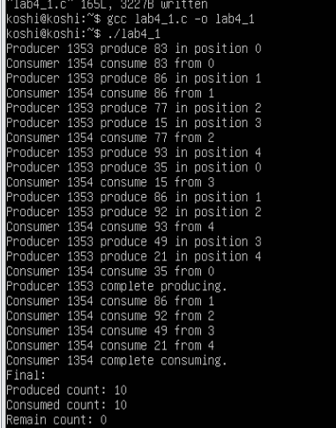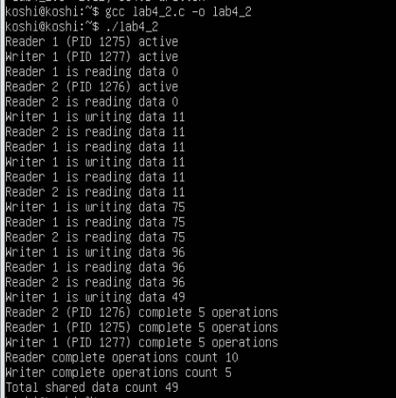

实验总结
本次实验通过编写两个程序，使用信号量分别解决生产者消费者问题和读者写者问题，对进程同步和pv操作有了更多的了解，且通过对比，也能体会到记录型信号量和信号量集之间的区别。

